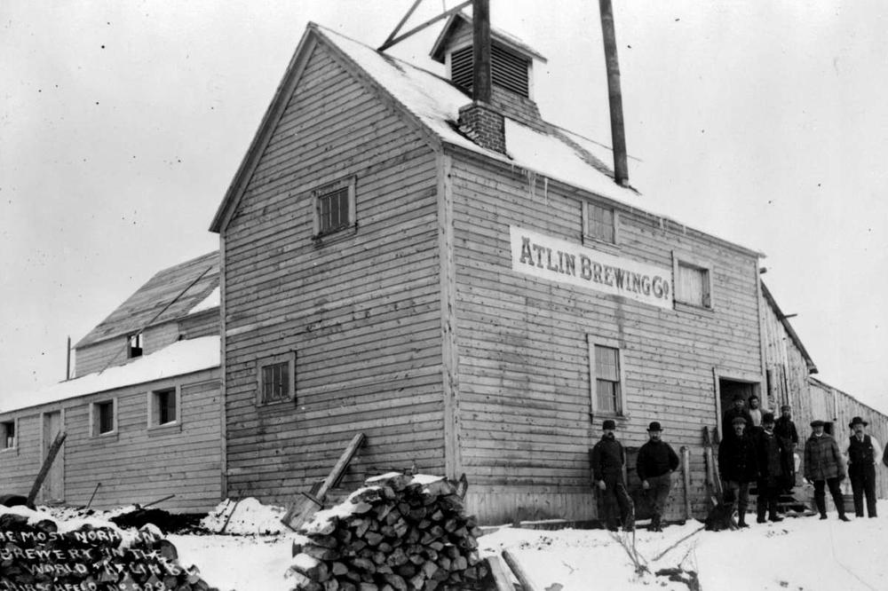 |  | AHS  - Newsletter  - October 2018  Atlin Historical Society  Box 111 Atlin BC V0W1A0  atlinhistoricalsociety@gmail.com  www.atlinhistoricalsociety.com  250 651 7522

Like us on Facebook!!

Note from the Executive
We are happy to report that the assessment of the Courthouse was completed with over 100 pages of documentation complete with thermographic studies! This report can be found on our website. With this report, feedback from our community survey and one on one interviews with community members and heritage professionals familiar with Atlin, the board had more than enough information to make decisions.
Our vision is that the Courthouse and indeed all of our buildings and assets be warm, welcoming, in good repair, accessible to the community, and self-sustaining.
The good news is that the Courthouse is structurally sound and just needs a complete makeover roof to footings. Needless to say this is going to cost considerably more than the $9242.22 spent to build and furnish in 1900! And, we have chosen to make a small addition on the rear of the building to accommodate a washroom, water and sewer tanks. This addition will also create another access point to a sunny porch with a ramp that in future could connect to pathways through the museum yard.
With the library and gallery anchoring the spaces, we can see opportunity in sprucing up the main hallway (heating and lighting) as people walk through to access the washrooms, rear porch area and the exterior ramp. Upstairs, the idea is to divide the space in half creating a residence (for rental) on one side and open space for community rental on the other.
Ever the optimists, the board has decided to move forward with a phased program to refurbish the building. The first task is to determine best approaches for funding such an endeavor. We are building our networks and searching for grant programs etc. 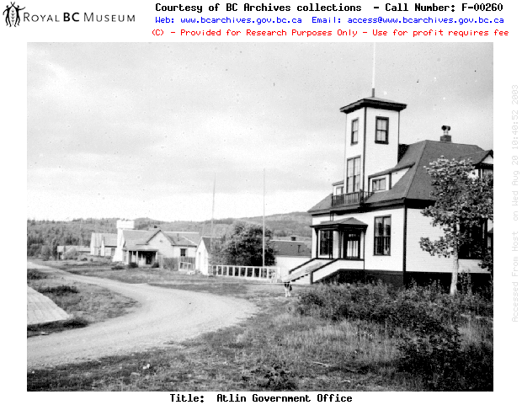
It is clear that Atlinites love their old buildings and rich history and so we are excited about the possibilities as we work towards the continued preservation and renewal of the Courthouse.
Again, we invite anyone interested in this process to feel free to join in.
Staff from the Rick Hanson Foundation were in Atlin this spring and assessed the Museum, Courthouse, and Globe Theatre for accessibility. We recently learned that none of the buildings certified as accessible by the RHF criteria. As a result of the assessment we become eligible for funding through the RHF which will help us make improvements in the future
Atlin’s historic resources play a huge role in local tourism and we participated with other community members to inform a province-wide strategy intended to serve as a guide for building BC communities as tourist destinations. This year the museum welcomed 1583 visitors!. A local group hosted a busload of tourists to a tea on the Tarahne, a walking tour and other activities. This was a huge success resulting in bookings for next year.
Fundraising activities are ever present and this year, along with the annual Tarahne Tea ($2976), a musical evening and bbq raised a new boiler and $4000 for the Globe’s heating project. Another new event: cocktails on the Tarahne and dancing in the Globe ( $2000) was organized by Amanda Fraser to rave reviews and promises to keep this as an annual event.
Canada Helps is a non-profit organization that assists Canadian registered charities with fundraising. The website provides an online platform to accept donations on behalf of all registered charities in Canada. The funds are automatically deposited to the charity and donors immediately receive tax receipts. In addition they offer many resources to assist charities with raising funds. We have benefitted recently by three donations in this way. Thanks to Duncan Sinclair (Jazz Yukon) both for the referral to this resource and the generous donation to the Globe fund.
Internet “research” can often lead us down all kinds of rabbit holes. Here are a couple of places I found that are perhaps not all that recent but were new to me so am sharing.
https://www.michaelkluckner.com/bciw10atlin.html This is a collection of paintings and historical bits compiled by Michael Kluckner.
http://littlebluehouse1898.blogspot.com/ A fun blog from the owners about the current restoration of “the little blue house.” 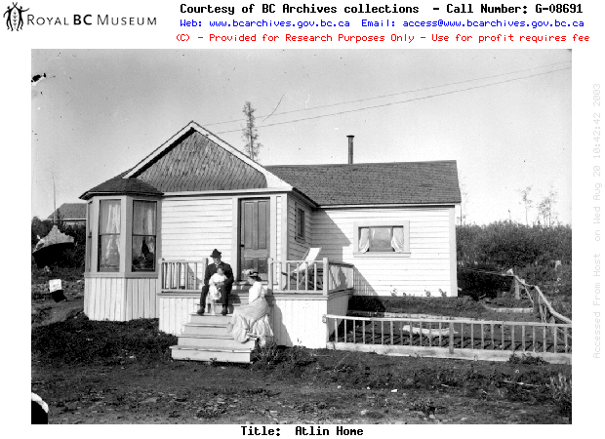
A membership form is included with this newsletter. We thank all of you for your support as members, volunteers, donors and friends.
Around Town
Globe Theatre – Currently waits for new boiler installation. Dana Hammonds is hopeful for an October 31 completion. Watch for posters announcing winter programming.
Tarahne – As mentioned previously, she needs a bit of attention: Waterproofing her top deck, new flooring on the main deck, some painting, fire suppression system, and assessment regarding erosion of the shoreline around the cribbing. We need to act on these items fairly urgently before they turn into bigger items. Funding is being researched. If you are interested in being part of this project, please let us know.
Tarahne Tea – July 6, 2019 !!! Mark your calendars.
Atlinto-The picnic area was well used around the Atlinto this summer. Having the coffee wagon nearby made it, and “Bob’s Bench” a perfect place to enjoy a relaxing moment.
Courthouse – Thanks to the Rural Dividend for the funding to hire Robin Urqhuart. He completed the assessment which was a crucial step in helping us to make a plan and secure funding to refurbish this 1900 gem. See AHS website for the complete report.
Archives/Museum – There were many archival inquiries over the summer and the new museum displays were well received. More plans in the works for the museum!
Gold Panning was a great success this summer, Nigel and a crowd of “miners” gathered in the yard to pan some gravel. Gold was found and people were excited! Thanks so much to Trent and Amber Wenzel for donating the gold!! The kids especially loved it.
Christmas Shopping? Don’t forget the Musuem Bookstore, there are many excellent choices, and we have the coolest giftwrap too! Call Patricia if you want to browse.
Thank You’s
I am sure I will miss someone which I regret because everyone is so important to the AHS. Without you, nothing would happen! So with gratitude to all those below and to those not mentioned (please remind me so I can note it for next time).
Lloyd Brown – Tarahne fire suppression, fixing sewer pipe, opening and closing boat. Making the interior deck lights work and fishing a cell phone out of the deck wall!
Al – Tarahne Fire Suppression.
Gary Thoma, support, fixing and ideas regarding the pump, boiler and all things mechanical at the Globe. And for organizing the trailer and chair storage for Globe event.
Jamie and Barb Tait – Auctioneering, lending trailer and storage for chairs, projector.
Amanda Fraser and crew for organizing the Night on the Tarahne
Heather Keny and crew for organizing Boiler Fundraiser
Patricia, Mary, Judy, Jane, for organizing Tarhane Tea
Edith, Manu, Athea, for organizing the tourism event on the Tarahne.
Emile, Jared, Robin, Fiona, Tristan, Roger, Joel and friend for doing the heavy lifting of the chairs in and out of the theatre.
Joe Beaudoin – de commissioning old boiler and readying for Dana to install.
Robin for the assessment of the courthouse, above and beyond.
Nigel Young and Trent and Amber Wenzel for “Gold Panning in the Yard”.
Katherine, Nigel, Patricia and Edith for another fantastic museum/tourist info centre season.
President/Chair: Anne Campbell
Vice President : Patricia Kother
Secretary: Vacant
Treasurer: Edith Sidler
Directors: Kate Fisher, Rose Anne Antilla, Susie Kuelbs, Nigel Young
Archivists: Susie Kuelbs, Helen Smith, Linda Reed, Edith Sidler

.
Please fill in the following form for your annual membership and either mail to the address below or drop it by the Museum. We will send you a membership card and receipt.
Name

Street Address/PO Box #

Town/City

Province/State

Postal/Zip Code

Membership - $20 per person | $
Donation (any amount but min. $10 for tax reciept. | $
Suggestions: Please indicate your preferred projec
t

Atlin Historical Society Box 111 Atlin BC V0W1A0 ∗ 250 651 7572 *atlinhistoricalsociety@gmail.com * www.atlinhistoricalsociety.com

