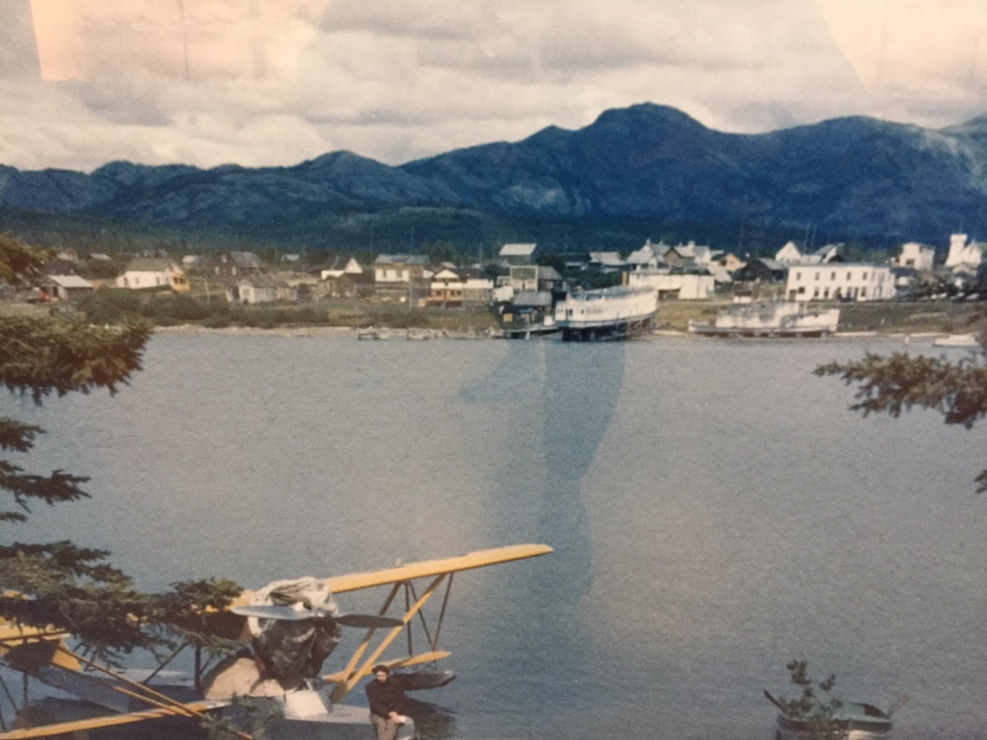 |  | AHS  - Newsletter  - May 2019  Atlin Historical Society  Box 111 Atlin BC V0W1A0  atlinhistoricalsociety@gmail.com  www.atlinhistoricalsociety.com  250 651 7522

Notes from the Executive
Happy spring! And doesn’t the downtown look amazing with all the grass trimmed and new shoots forming! A huge Thank You to Insa and her band of mowers, whackers and packers. The Courthouse, Museum, and Globe yards look wonderful.
Winter found the AHS board busy with a variety of activities. Our archivists responded to many inquiries via our website, There is a new display being planned for the museum, and we followed up on some funding opportunities.
Being in Victoria this winter allowed me some time to connect with various government folks regarding funding for a couple of our larger projects – the Courthouse and the Tarahne. There are several funds that we are potentially eligible for and all of the government people I met were very helpful and sympathetic to our cause. The process, however, is daunting. Each grant has no less than 30 some pages of “Guidelines” which must be read and analyzed to our situation, and then there are the various ways of budgeting and financial requirements for each fund. Each has a different split and each has different

ways to itemize expenditures and each fund has different deadlines so opportunities for “stacking” are somewhat thwarted. This is weeks of work to prepare and we are competing not only with other non -profits but also municipal governments and legions of paid staff. While I am grateful there is some funding out there, the cost to the organization asking for the funds, in this case the AHS is huge and requires enormous effort and responsibility. And let’s not forget the cash flow issues if we are successful. The way funds are dispersed is different with each grant but generally we need to spend the money first and then the grant will reimburse. Tricky if you are a non- profit without a line of credit or cash! Simple but complicated and time consuming and it is a learning curve that builds skills.
I have to ask myself how this got so complicated. I suspect it is a political requirement but the process seems geared towards the bureaucracy rather than the applicant. This is a question that I will put to our Minister Donaldson when I report to him on my experience with his bureaucracy on behalf of the AHS.

Meanwhile, fingers crossed some funds do manage to come our way!
Dates To Remember
Museum opens May 3 – Sept. 9
AGM – June 1, 3:00 p.m.
AHS Strategic Planning – May 24-25
Tarahne Tea – July 6
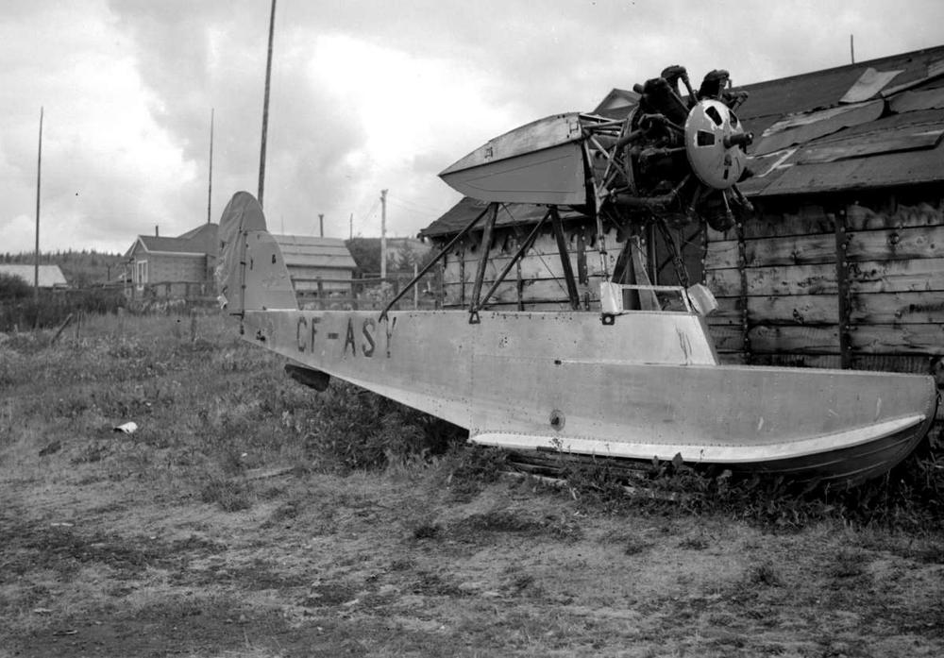
Eastman Flying Boat
A visit to the Transportation Museum near the Victoria airport to see the Eastman Flying Boat restoration was a wonderful experience. The museum is run by volunteers and funded only by donations. They have amassed a collection of flying machines that is truly impressive. Because the Eastman has its roots in Atlin, Kate Fisher was able to obtain a copy of the logs containing a wonderful story of flying around Atlin in the 1920’s. Kate also had a print made of the photo you see at the top of this newsletter. Thanks Kate!!
5 Yr. Strategic Plan
It is time for us to develop a new 5 year plan. And we have scheduled May 25-26 to get it done. If you are interested in helping us create a strategy to guide the society for the next 5 years, please call Anne at 651 7773 for more details.
New Museum Display
We are fundraising for, and excited about a new display currently being planned for the museum. The idea is to show how transportation had a huge impact in the development in British Columbia’s far northwestern corner.
Transportation by First Nations on the lakes, rivers and through the stark mountain passes created a support economy for the gold rush and later that same infrastructure created a market for Tourism in the 1920’s
The central point of focus is a wall map covering both the British Columbia, and Alaskan border on both sides from the Stikine River drainage in the southeast, to include the White Pass, Chilkoot Pass, Atlin Lake and surrounding Lakes in the northwest.
The display will be further supported with historical photos of places and types of transport used from the AHS photo collection and additional items of historical merit from the AHS collection.
Although the time to develop the display is volunteered, various materials are budgeted to come close to $5000, which includes the development of a very detailed and large map. If you are interested in donating towards this new display, or have other interest or questions, please contact Anne.
Passings
We would like to acknowledge the contribution to the AHS of three of our former members:
Edith Nelson
Evelyn Colwell
Dorothy Smith
Our gratitude to them for working towards the preservation of Atlin’s History and our condolences to all of the families.

Around Town
Globe Theatre – With the new boiler and most of the holes plugged with insulation (Thanks Robin Urquhart), Heather reports a substantial savings in heating costs this winter over last! Yay! Heather has been working hard to bring a variety of programming to the theatre and making improvements to our comfort. Thanks Heather, well done.
Tarahne – As mentioned previously, she needs a bit of attention: Waterproofing her top deck, new flooring on the main deck, some painting, fire suppression system, and assessment regarding erosion of the shoreline around the cribbing. We need to act on these items fairly urgently before they turn into bigger items. Funding is being researched. If you are interested in being part of this project, please let us know.
Tarahne Tea – July 6, 2019 !!! Mark your calendars.
Archives/Museum – As previously mentioned there were many archival inquiries over the winter and the new display in the works. The new digitally created map promises to be an exciting addition to our museum.
We hope to keep the museum open 7 days a week again this summer and with Patricia’s generous donation we probably will be able to do just that. If you are a business in town and want to get the word out to our visitors, please make sure Catherine is aware of your services and hours of operation. Over 2000 visitors each year stop by our Museum and Visitor Centre so it is important to keep us up to date to be able to send visitors your way. As always, your generous donations help us to keep this service alive!
Thank You
I am sure I will miss someone, which I regret because everyone is so important to the AHS. Without you, nothing would happen! So with gratitude to all those below and to those not mentioned (please remind me so I can note it for next time).
Tristan Odian, for noticing and replacing the flag on the Tarahne
Robin and Karen Armour for noticing and replacing the flag at the Courthouse.
Insa Schultenkotter, Bob Wagner, Andrea Ross, John Bellamy, Lloyd Brown, Dale and Lorraine Jenkins for cutting the grass around the Courthouse, Museum, and Globe theatre.
The anonymous donors of the china teacups left at the museum.

President/Chair: Anne Campbell
Vice President: Patricia Kother
Secretary: Vacant
Treasurer: Edith Sidler
Directors: Kate Fisher, Rose Anne Antilla, Susie Kuelbs, Nigel Young
Archivists: Susie Kuelbs, Helen Smith, Linda Reed, Edith Sidler

.
Please fill in the following form for your annual membership and either mail to the address below or drop it by the Museum. We will send you a membership card and receipt.
Name

Street Address/PO Box #

Town/City

Province/State

Postal/Zip Code

Membership - $20 per person | $
Donation (any amount but min. $10 for tax reciept. | $
Suggestions: Please indicate your preferred projec
t

Atlin Historical Society Box 111 Atlin BC V0W1A0 ∗ 250 651 7572 *atlinhistoricalsociety@gmail.com * www.atlinhistoricalsociety.com

