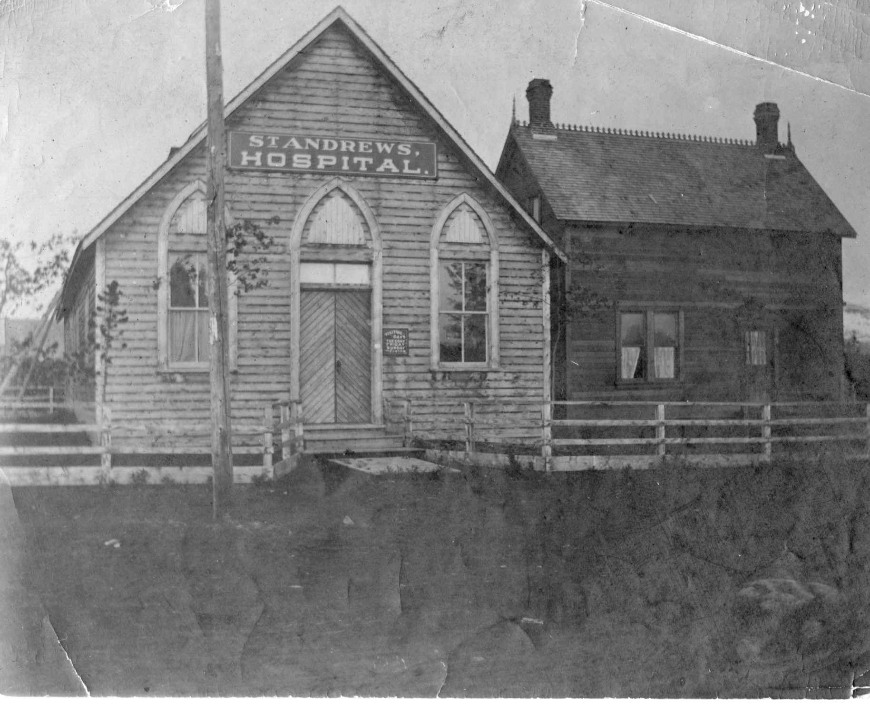 |  | AHS  - Newsletter  - June 2020  Atlin Historical Society  Box 111 Atlin BC V0W1A0  atlinhistoricalsociety@gmail.com  www.atlinhistoricalsociety.com  250 651 7522

Notes from the Executive
This spring, as is the case around the world, we have good news and we have bad news! And if history is to inform us at all, we still need to be vigilant as the possibility of a second wave of COVID 19 making its way to Atlin is very real.
Due to pandemic conditions the board has decided to postpone most, if not all programs and events. This means that there will be no Tarahne Tea, the Courthouse Gallery will be closed for the time being as is the Library. The Globe Theatre is closed for most events except those where social distancing can be maintained. And the museum will not open this spring as it is still in disarray as the travel restrictions meant that the team could not complete the new display as planned. However, we are doing what we can do and hoping for the best!
Also this winter we had a small disaster in the Archives when the oil heater decided to break down and spill a wee bit of its oil onto the floor. No real damage but a new heating system and ridding the building of the oil smell is on the top of our list. We haven’t made any decisions yet and still thinking over our options. Many thanks to Stacey, Mike Strange, Dana Hammond, and Edith and Manuel for all they did to help in this situation.
The good news is that our friends at BC Heritage were able to grant us funds that will address all of the needs of the Tarahne to bring her up to a new standard to last into the next decade!
Amazing support from Richard Linzy, Gord Macdonald and Ben Gourly of BC Heritage Branch and Heritageworks. The total grant funds with the earlier grant of $14,000 from the BC Legacy Fund brings us to $89,000. Travel restrictions still hamper us but with the help of local craftspeople we are hopeful we can get started as weather permits.
Read the Heritageworks report posted on our website, of their findings after a tour of some of Atlin’s history last fall.
Once again our friend Hugh has come aboard with a wonderful offer to assist with the Courthouse upgrade project. We hope to move forward with that project as time and travel and gathering restrictions ease over summer and into the fall.
AGM – June 28, 2020
This is to be Anne’s last year as Board member due to other personal commitments. Edith is also interested in stepping down as Treasurer and just focusing on the Archives.
The work of the Atlin Historical Society is huge and 4 people on the board do not allow for much to get done, really just the immediate and necessary things. We think this can be whittled down if there are more people to take on the tasks. For example:
- Fundraiser, grant applications, raffle organizers,
- Event Organizer and event workers
- Building Maintenance Supervisor
- Building maintenance workers
- Grounds keeping – Thanks to Karen Smallwood who will return this summer – Yay!
There are other ideas and ways of going about this and we are hopeful that a few people out there would be interested in diving in to this very worthwhile cause!
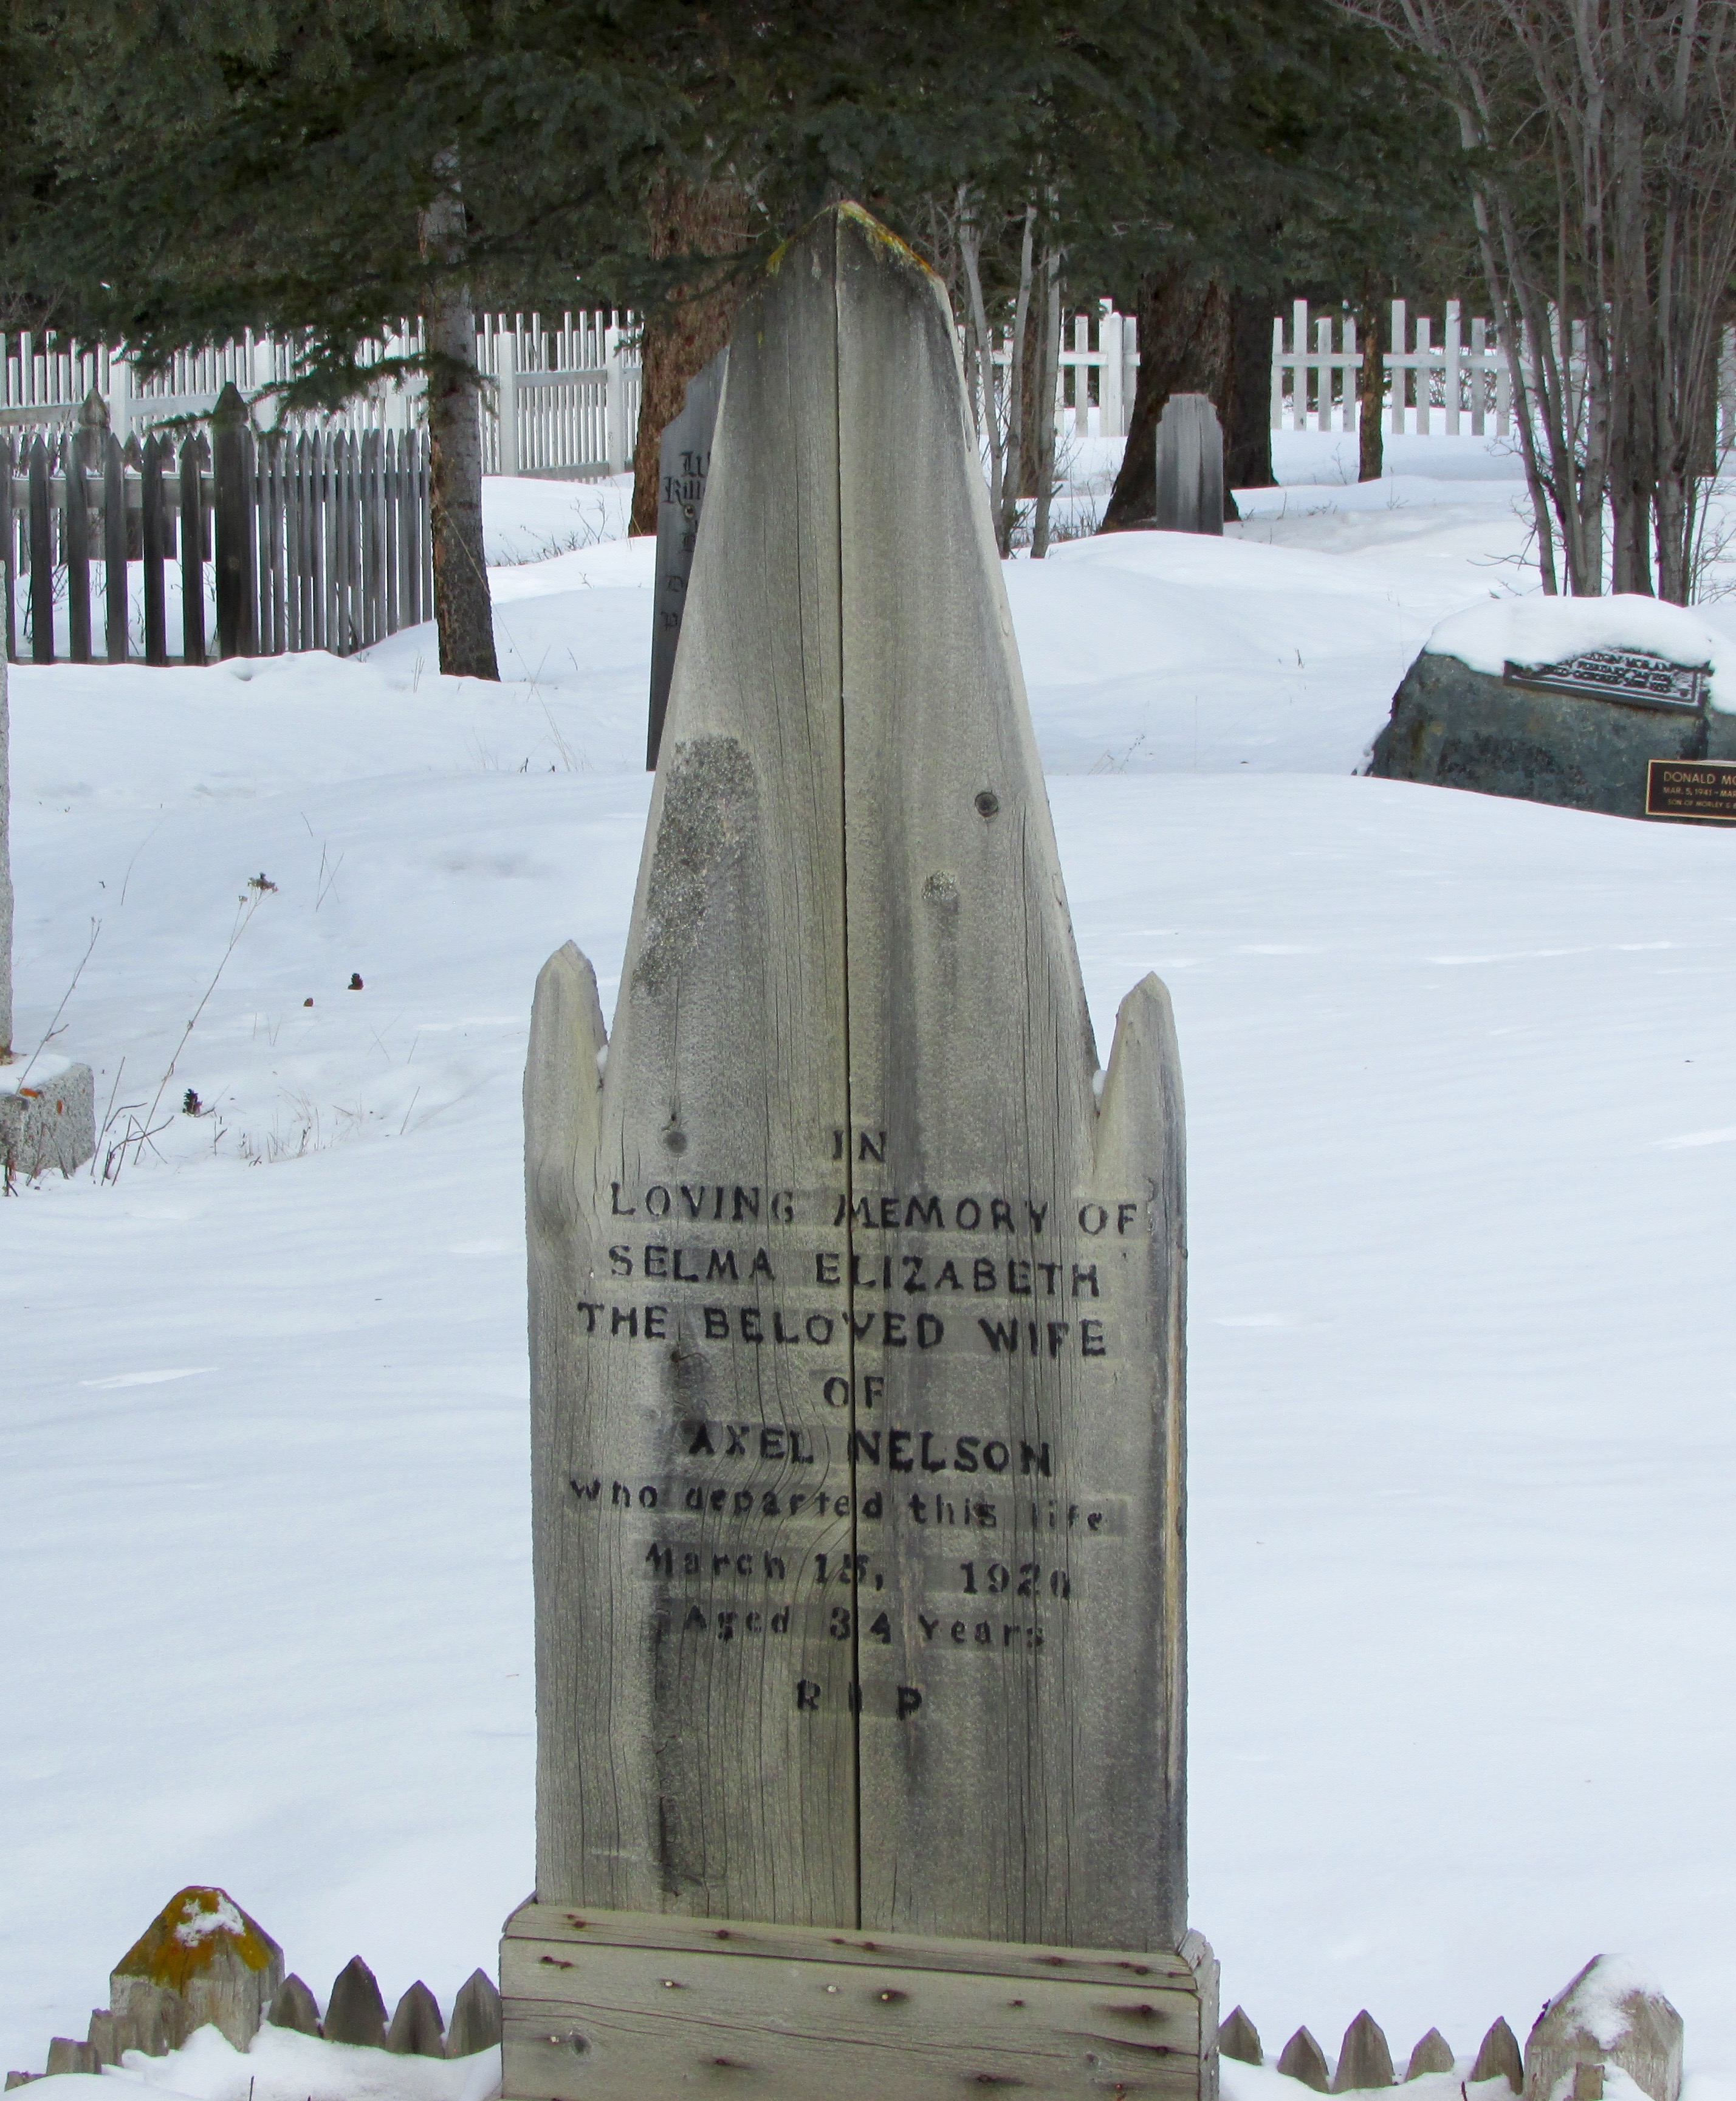
Learning from Our Past
Over 100 years ago the first wave of the influenza epidemic hit the north, starting in Nome, Alaska and spreading throughout Alaska. The flu was rumored to have been aboard the Princess Sofia on her final voyage from Skagway in late October of 1918. And two weeks later the first death was reported at Fort Seward in Haines, Alaska.
Both Alaskan and Yukon governments responded with quarantine orders for all passengers arriving north on the ships. Local Skagway residents returning home were housed in the ‘Hospital Annex’ next to the White Pass Hospital in Skagway. Those folks bound for the Yukon went to a ‘Best House’ on Main Street in town. Families in town helped to provide food for all those in quarantine for 5 days. These quarantines happened with every ship arriving in Skagway through the fall and winter of 1918. During the winter months there was one northbound train a week on Thursdays, and one southbound on Fridays.
With the coming of the New Year the pressure was on for lifting the quarantine in the anticipation of returning miners and mining activity, and the quarantine was lifted on Feb 27,1919. The coming of March brought milder weather, along with soldiers and miners returning home to the north.
Atlin’s first outbreak of the influenza virus came in March of that year. It attacked the young and strong as well as the elderly. Atlin closed the school for the balance of the school year. Resources and nurses at St. Andrew’s Hospital were stretched to their maximum. But the real challenge was still to come.
In the spring of 1920 the virus returned with a vengeance. At its height there were 50 folks ill in both Atlin and Discovery. Nineteen people died and new crosses began appearing in the cemetery. The Taku River Tlingit people were hit the hardest with 15 souls lost to the virus.
Doctors and Nurses at St. Andrew’s Hospital worked to the point of exhaustion. Local folks stepped forward to help in any way possible, including the Post Master Thomas James. With some experience as a druggist he worked along side the hospital staff until his own death from the virus.
Atlin The Story of British Columbia’s Last Gold Rush Dickinson/Smith
https://skagwaynews.com/2020/04/13/under-the-boardwalk-skagway-has-been-through-this-before-what-we-can-learn-from-the-1918-19-pandemic/
Story Behind the Headboard
Selma Elizabeth Erickson, from Lulea, Sweden, arrived in Atlin in 1916. She came as a cook. Axel Nelson, from Borgholm, Sweden on the island of Oland, came to Atlin in the early 1900's during the gold rush. He mined on Spruce Creek with a couple different partners. Axel and Selma were married on Aug. 21, 1917 and lived on Spruce Creek. They had a son, George, born Jan. 4, 1918, then a daughter, Dorothy, born March 9, 1920.
Selma died of the flu in the St. Andrews Hospital on March 15, 1920. She was 34 years old. Dorothy was only a week old. Axel realized he could not look after his tiny daughter so asked Pete and Margaret Matson (Ted Matson's parents) if they would take care of her. They adopted her and gave her a wonderful life in Atlin. George was fostered in the community until he was about 10 years old and then joined his father on Spruce Creek.
Axel Nelson never remarried. He left Atlin in the 1940’s and moved to Prince Rupert to live with George and his family. In his later years he became a fisherman and passed away in the early 1950’s.
Thank You to:
- Barb and Jamie Tait and the Atlin sewing group for new tea tablecloth fabric and turning them into new cloths for the Tarahne Tea!
- Stacey, Mike Strange, Dana Hammond, Edith Sidler, Manuel Sidler for helping with the Archives heating.

.
Not a member? Please fill in the form and either mail to the address below or drop it by the Museum. We will send you a membership card and receipt.
Name

Street Address/PO Box #

Town/City

Province/State

Postal/Zip Code

Membership - $20 per person | $
Donation (any amount but min. $10 for tax reciept. | $
Suggestions: Please indicate your preferred project

Atlin Historical Society Box 111 Atlin BC V0W1A0 ∗ 250 651 7522 *atlinhistoricalsociety@gmail.com * www.atlinhistoricalsociety.com

